Asesoramiento de Hosting

Nombre: Álvaro García Torres
Curso: 2ºDAW

Índice

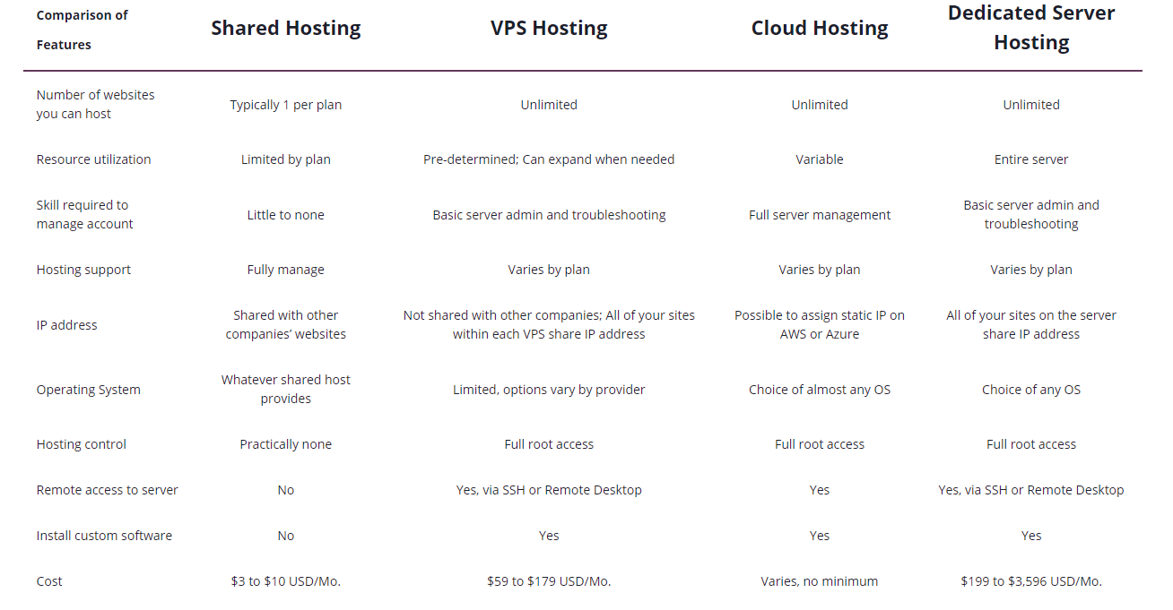

A2

Blazing Fast, Low Cost Web Hosting
Our ultra-reliable,high-performance web hosting is here to help you and your sites succeed. You can even choose to host on ourTurbo Servers for page load speeds up to 20X faster than those competing hosting solutions!

faster sites have better SEO rankings, lower bounce rates and higher conversion rates.

Up To 20X Faster Turbo
That means better SEO rankings, lower bounce rates & higher conversion rates!

Guru Crew Support
Our friendly and knowledgeable support team is available 24/7/365 to help!

Free Account Migration
Our team can move your site to A2 Hosting for free in most cases!

Money-Back Guarantee
Give our high speed hosting service a try completely risk-free!

99.9% Uptime Commitment
A2 Hosting is the host you can depend on with ultra-reliable servers!

MOVE EXISTING SITE TO A2 HOSTING
We'll migrate your website to our servers for FREE!
- Free Site Migration
- Expert Site Migration Team
- Fast & 100% Worry-Free!

BUILD A NEW SITE
Use the easy A2 SiteBuilder to create a new custom site!
- Easy Drag & Drop Editing
- Free, Attractive Themes
- Fast Website Publishing

A2 | Stratup | Turbo
N.º de websites | 1 | Ilimitadas
GB | 100GB | Ilimitadas NVMe
Tráfico | Ilimitado | Ilimitado
SSL | Gratuito | Gratuito
Backup | Configurable | Gratuito
CDN | Gratuito | Gratuito
Bases de datos | 5 | Ilimitadas
Precio | 2,99$/mes | 6,99$/mes

SiteGround

Website Building
Need a website but not sure where to start? Get started with a full website solution including your choice of sitebuilder: WordPress or Weebly and launch your site quickly and easily!

Website Transfer
Transfer your website to us worry-free with the help of our migration experts. Or, enjoy free automated migrations with our easy-to-use WordPress Migrator plugin.

Ecommerce
If you are planning on building an online store, our hosting plans offer an integral ecommerce solution. Starting with the free installation of the shopping cart of your choice: WooCommerce, Prestashop, or OpenCart and adding free features such as SSL, daily backups and more to the bundle.

CMS Applications
Our hosting platform is optimized to support multiple PHP-MySQL-based CMS and CRM applications. Should you choose to build your site with a CMS, we offer free installation of the most popular ones such as: WordPress, Drupal, Joomla, and more.

Ultra-fast Sites
Our hosting platform is built on Google Cloud and uses its ultra-fast network and SSD persistent storage. On top of it we add our own server setup with multiple custom speed optimizations.

Top-notch Security
We manage the security of your sites at server and application level. We offer free Let’s Encrypt SSL that keeps your data safe and daily backups that ensure your peace of mind.

Reliable Email Service
Create an unlimited number of email accounts with your own domain and check your email from anywhere with our friendly webmail clients. We’ve added SpamExperts to protect you from SPAM.

Easy Site Management
Easily manage your site built on the most popular Content Management Systems such as Joomla, WordPress, and more. Get started with our friendly Site Tools, packed with tons of features that save you time and effort.

Domain Management
Enjoy the convenience of managing both your domain and site in the same place. We offer affordable domain registration and transfer services, a friendly domain management panel, DNS services, and more.

6.99 €/mo.
- Unlimited Websites
- 20 GB Web Space
- ~ 25,000 Visits Monthly
- Unmetered Traffic
- Free SSL
- Daily Backup
- Free CDN
- Free Email
- Managed WordPress
- Out-of-the-box Caching
- Unlimited Databases
- 100% renewable energy match
- 30-Days Money-Back
- Add Collaborators
- On-demand Backup Copies
- Ultrafast PHP
- Staging

SiteGround
N.º de websites | 1
GB | 10GB
Visitas mensuales | ~ 10,000
Tráfico | Ilimitado
SSL | Gratuito
Backup | Diario
CDN | Gratuito
Email | Gratuito
Bases de datos | Ilimitadas
Precio | 3,99 €/mes

Hostinger

Ofrece diferentes planes y tarifas dependiendo del tipo de hosting que elijas, presentando opciones de Hosting compartido, dedicado, VPS, WORDPRESS, y Cloud.

D

